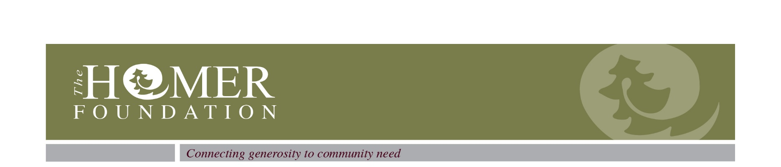
PO Box 2600. Homer, AK 99603. 907-235-0541. info@homerfoundation.org. www.homerfoundation.org

Letter of Inquiry Instructions

For grants over the amount designated for the Quick Response Grant, a letter of inquiry to the Board of Trustees starts the application process. This letter helps us determine if your organization and project are of interest and eligible for grant consideration; if so, you will be invited to submit a full application to the Board of Trustees. After receipt of your letter, it will be considered at the next regularly scheduled Board meeting. The Board typically meets the fourth Wednesday of the month excluding July and November. There are no deadlines for submission, however there is a minimum of a 3 month timeline for a final decision with this process.

In this letter of intent, please include:

- A brief background of your organization, including a mission statement; date founded; staff and board size; constituency and geographic region served; type(s) of service provided; and annual operating budget size.
- A description of the project a Homer Foundation grant would support. Discuss how you reached the decision to pursue this project; factors contributing to the need or opportunity; the project’s importance to your organization and constituency; and the level and nature of commitment of your staff and board. Also include beginning and end dates for this project.
- A proposed budget, in summary form, for the total project cost and the amount you intend to request from the Homer Foundation. If possible, identify the specific budget item(s) to be funded by Foundation support, and indicate potential or actual sources of support outside of the Foundation.
- Your reasons for approaching the Foundation for this project, including community benefit and the number of community members benefiting from this project. Disclose any past history with the Foundation or any contact you’ve made with Foundation staff or others that may have influenced your decision. Please note any other factors you believe would help us understand your situation and request.

We request that this narrative should not exceed three typed single space pages, excluding financial data. Once complete, send your letter to Homer Foundation staff. Please contact the office if you have any further questions.

